**HOTEL MANAGEMENT SYSTEM**

A Dissertation submitted in

partial fulfillment of the requirement for the award of Degree of

**MASTER IN INFORMATION TECHNOLOGY**

Submitted By

**B. RAHMAN**

(**Register No**: 31918P19003)

Under the guidance of

Prof. **A. Kaleemullah** M.Sc., M.Phil., S.E.T.,



A project submitted to

**P.G. Department of Information Technology.**

**Mazharul Uloom College**

**AMBUR – 635802**

**March – 2020**

**ACKNOWLEDGEMENT**

First and Foremost, I express my gratitude to Almighty whose blessing upon me, and his grace cover all the time to complete my projects. I would like to thanks my parents whose endless supports and encouraging made my projects a bit lighter.

I would like to thanks **Dr. M. Mohammad Yunus** , M.Sc, Ph.D., the principal of the Mazharul Uloom College, Ambur for kind support to allow projects completion.

I express a sincere gratitude to **Dr. P. Rizwan Ahmed** M.C.A., M.Sc., M.A., M.Phil., Ph.D. the Head of the Department of Information Technology, Mazharul Uloom College, Ambur for the endless support and guide to share the valuable ideas in completion of the projects

I like to thanks Prof.**A. Kaleemuallah** M.Sc.,M.Phil.,S.E.T, the associated professor of Information Technology,Mazharul Uloom College, Ambur as a guide and leader for the support in completing of my projects.



**CERTIFICATE**

This is to certify that the projects titled ” **HOTEL MANAGEMENT SYSTEM** ” is Bonafide and work done by

**B. RAHMAN**

(Register No: 31918P19003)

In partial fulfilment of the requirement for the award of “ **M.Sc in Information Technology**”.

Signature of the Guide Head of the Department

(Prof. A. Kaleemullah M.Sc., M.Phil., S.E.T.,)

The viva-voce examination of this projects is held on ________________

**External**

1.

2.

**SYNOPSIS**

This project aims at creating on Hotel Management System which can be used by Admin and Customers. The admin to advise/publish the availability of rooms in different hotels and customers are checking the availability of room in required hotel. Customers should be able to know the availability of the rooms on a particular date to reserve in hotel. They should be able to reserve the available rooms according to their need in advance to make their stay comfortable. The Admin hands the booking information of customers. The users can register and log into the system. The administrator will know the details of reservation and daily income. The hotel department maintain the seat availability and booking details in certain database. This project provides high security to Admin and user information.

**CONTENTS**

|  |  |  |
| --- | --- | --- |
| **No** | **Title** | **Page No** |
| 1 | Introduction   * Lifecycle of JSP | 06 |
| 2 | System Analysis | 07 |
| 3 | System Configuration   * Hardware Requirement * Software Requirement | 09 |
| 4 | Project Description   * Existing system * Proposed system | 10 |
| 5 | System Design   * Context level Design * Dataflow Diagram * Database Design | 12 |
| 6 | Software Testing   * Black Box Testing * White Box Testing * System Testing * Unit Testing | 16 |
| 7 | Source Code | 18 |
| 8 | Screen Shot | 30 |
| 9 | Conclusion | 33 |
| 10 | References & Bibliography | 34 |

**Introduction**

The goal of any system development is to develop and implement the system cost effectively user-friendly and most suited to the user’s analysis is the heart of the process. Analysis is the study of the various operations performed by the system and their relationship within and outside of the system. During analysis, data collected on the files, decision points and transaction handled by the present system. Different kinds of tools are used in analysis of which interview is a common one.

The first step in system development life cycle is the identification of need of change to improve or enhance an existing system. An initial investigation on existing system was carried out. The present system of hospital is completely manual. Many problems were identified during the initial study of the existing system.

**MySQL:**

MySQL is the world's most popular open-source database. Despite its powerful features, MySQL is simple to set up and easy to use. MySQL is a powerful relational database application. It targets the desktop category and works for individuals and workgroups manging megatbytes of data. For multi-user access to the same database, access uses file-server architecture ,rather than client-server architecture.MySQL is a fast, easy-to-use RDBMS being used for many small and big businesses. MySQL is developed, marketed and supported by MySQL AB, which is a Swedish company.

MySQL is released under an open-source license. So you have nothing to pay to use it. MySQL is a very powerful program in its own right. It handles a large subset of the functionality of the most expensive and powerful database packages. MySQL uses a standard form of the well-known SQL data language. MySQL works on many operating systems and with many languages including PHP, PERL, C, C++, JAVA, etc.

MySQL works very quickly and works well even with large data sets. MySQL is very friendly to PHP, the most appreciated language for web development. MySQL supports large databases, up to 50 million rows or more in a table. The default file size limit for a table is 4GB, but you can increase this (if your operating system can handle it) to a theoretical limit of 8 million terabytes (TB).MySQL is customizable. The open-source GPL license allows programmers to modify the MySQL software to fit their own specific environments.

**Java Server Page (JSP):**

JSP technology is used to create dynamic web applications. JSP pages are easier to maintain then a Servlet. JSP pages are opposite of Servlets as a servlet adds HTML code inside Java code, while JSP adds Java code inside HTML using JSP tags. Everything a Servlet can do, a JSP page can also do it.

JSP enables us to write HTML pages containing tags, inside which we can include powerful Java programs. Using JSP, one can easily separate Presentation and Business logic as a web designer can design and update JSP pages creating the presentation layer and java developer can write server side complex computational code without concerning the web design. And both the layers can easily interact over HTTP requests.

**Life Cycle of JSP:**

A Java Server Page life cycle is defined as the process started with its creation which later translated to a servlet and afterward servlet lifecycle comes into play. This is how the process goes on until its destruction.

JSP pages are converted into Servlet by the Web Container. The Container translates a JSP page into servlet class source(.java) file and then compiles into a Java Servlet class.

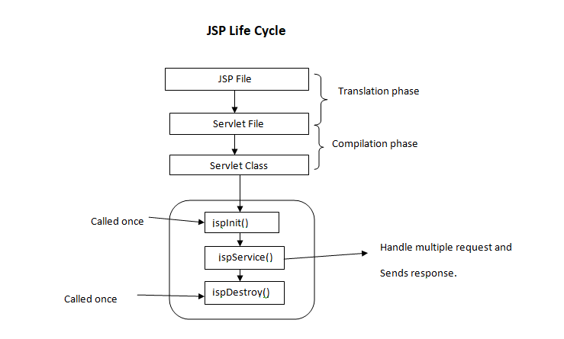

**Following are the JSP Lifecycle steps:**

1. Translation of JSP to Servlet code.
2. Compilation of Servlet to bytecode.
3. Loading Servlet class.
4. Creating servlet instance.
5. Initialization by calling jspInit() method
6. Request Processing by calling _jspService() method
7. Destroying by calling jspDestroy() method

**SYSTEM CONFIGURATION**

**Hardware Requirements:**

Processor : Intel dual core processor

RAM : Minimum 2 GB

Monitor : 15” Colour Monitor

Hard disk : Minimum 40 GB

**Software Requirements:**

Operating System : Windows 7, 8, 10

Front-End : JSP Technology

Back-End : MySQL

Scripting : Javascript

Server : Apache Tomcat 7.0

**Project description**

The Hotel Management System is used to provide the better faculty and facility for the customer. This system uses recent technology to satisfies the management of the hotel user. In this projects the user can book room, Check-out the room. The administrator can easily check the availability of the room. Check-out, reservation on fingertip.

**Existing System**

In the existing system, only provides the information about particular hotel and only some of the hotels has possibility to reserve the rooms. The previous system was failure to publish the room’s availability of multiple hotels. And, it is failure to provide defence to admin and user information.

**System analysis can be categorized into four parts.**

* System planning and initial investigation
* Information gathering.
* Applying analysis tools for structured analysis.
* Feasibility study.

**Proposed System**

The hotel management system provides the quality service to the end user. This project aims at creating on Hotel Management System which can be used by Admin and Customers. The admin to advise/publish the availability of rooms in different hotels and customers are checking the availability of room in required hotel. Customers should be able to know the availability of the rooms on a particular date to reserve in hotel. They should be able to reserve the available rooms according to their need in advance. To make their stay comfortable. The Admin hands the booking information of customers. The users can register and log into the system. The administrator will know the details of reservation and daily income.

**ADVANTAGES:**

* To overcome the problems of Existing System, online hotel management system is proposed.
* It provides the good publishing services to end users. Means the admin can publish the availability of rooms in different hotels and this information visible at users/customer side. So, it providing the good publishing process.
* The central objective of hotel management is to provide online facility for booking rooms.

**DATA FLOW DIAGRAM**

**CONTEXT LEVEL DIAGRAM:**

**DATAFLOW DIAGRAM**

ADMIN

Login

Condition

Home

Booking

Check-In

Check-Out

Log out

**DATABASE DESIGN**

**Table Name**: Booking

|  |  |  |
| --- | --- | --- |
| Name | Type | Size |
| Customer Name | Varchar | 25 |
| Customer Address | Varchar | 40 |
| Customer Contact | Varchar | 25 |
| Customer ID | Varchar | 40 |
| No of Person | Varchar | 25 |
| Room Type | Varchar | 25 |
| Booking Date | Date | 10 |

**Table Name:** Check-In

|  |  |  |
| --- | --- | --- |
| Name | Type | Size |
| Customer Name | Varchar | 25 |
| Customer ID | Varchar | 25 |
| Checking Date | Date | 10 |
| No of person | Varchar | 25 |
| Room type | Varchar | 25 |
| Room Allocate | Varchar | 25 |

**Table name:** Check-Out

|  |  |  |
| --- | --- | --- |
| Name | Type | Size |
| Customer Name | Varchar | 25 |
| Customer ID | Varchar | 25 |
| Check-in Date | Date | 10 |
| Check-Out Date | Date | 10 |
| Room Number | Varchar | 25 |
| Room Stay | Varchar | 25 |
| Total Amount | Varchar | 25 |

**SYSTEM TESTING**

**Introduction**

Software testing is an investigation conducted t provide stakeholders with information about the quality of the product or service under test. Software testing can also provide an objective, independent view of the software to allow the business to appreciate and understand the risk of software implementation. Test techniques include the process of executing a process of executing a program or application with the intent of finding software bugs(errors or other defects). It involve the execution of a software component or system to evaluate one or more properties of interest.

**Black Box Testing:**

Black Box Testing is a software testing method which is used to test the software without knowing the internal structure of code or program. The main purpose of the Black Box is to check whether the software is working as per expected in requirement document and whether it meet the user expectation or not. Tester only passes valid as well as invalid input and determine the correct expected outputs. All the test using such methods are calculate based on requirement and specification.

**White Box Testing:**

White Box testing is also known as Code based Testing or Structural Testing. White Box testing is the software testing method in which internal structure is being known to tester who is going to test the application. Testing Based on analysis of the internal structure of the component or system. While unit, integration and system levels of the software testing process, it is usually done at the unit level. It can test path with a unit, path between units during integration, between subsystem during a system-level test.

**System Testing:**

System Testing or end-to-end testing is a completely integrated system to verify that it meets its requirement, For Example, a system test involve the testing a logon interface, then creating and editing an entry , plus sending or printing results, followed by summary processing or deletion of entries, then logoff. In addition to , application testing . It ensure that the program , as well as working expected, does not also destroy or partially corrupt its operating environment or cause other processes within that environment to become inoperative or not consuming or locking up excessive resource and parallel process unarmed by its presence.

**Unit Testing:**

Unit testing is software development process that involves synchronized application of a broad spectrum of defect prevention and detection strategies in order to reduce software development risk , time , cost. It is performed by the software developer or engineer during the construction phase of the development cycle, rather the replace the traditional QA focus and it arguments.

**Overview:**

Function test provide systematic demonstration that function tested are available as specified by the business and technical requirements, System documentation and user manuals. Functional testing is centered on the following items.

Valid Input : identified classes of valid input must be accepted.

Invalid Input: identified classed of invalid must be rejected.

Functions: identified functions must be exercised.

Output: identified classes of application output must be exercised.

System/procedure : Interfacing system or procedure must be invoked.

**SOURCE CODE**

**Index.html**

<!DOCTYPE html PUBLIC "-//W3C//DTD HTML 4.01 Transitional//EN" "http://www.w3.org/TR/html4/loose.dtd">

<html>

<head>

<meta http-equiv=*"Content-Type"* content=*"text/html; charset=ISO-8859-1"*>

<title>Hotel Management System</title>

<style type=*"text/css"*>

*{

margin:*0px*;

padding:*0px*;

box-sizing:*border-box*;

}

**body**{

background: *url("img/hotel1.jpg")*;

background-attachment: *cover*;

}

*.log*

{

background-color: *#111*;

position: *absolute*;

top:*70%*;

left:*50%*;

transform:*translate(-30%,-30%)*;

}

*.log* **a**{

text-transform: *Uppercase*;

font-size: *36px*;

color: *White*;

}

*.log* **a***:hover*{

color: *green*;

}

</style>

</head>

<body>

<div class=*"log"*>

<a href=*"login.html"*>Login</a>

</div>

</body>

</html>

**Login.html:**

<!DOCTYPE html PUBLIC "-//W3C//DTD HTML 4.01 Transitional//EN" "http://www.w3.org/TR/html4/loose.dtd">

<html>

<head>

<meta http-equiv=*"Content-Type"* content=*"text/html; charset=ISO-8859-1"*>

<title>Hotel Management System</title>

<link type=*"text/css"* rel=*"stylesheet"* href=*"newcss.css"*>

</head>

<body>

<div class=*"login"*>

<form action=*"loginprocess.jsp"* method=*"post"*>

<h1> Login </h1>

<input type=*"text"* name=*"uname"* placeholder=*"Enter your Username"*>

<input type=*"password"* name=*"pass"* placeholder=*"Enter your Password"*>

<input type=*"submit"* value=*"Login"*>

<input type=*"reset"* value=*"Cancel"*>

</form>

</div>

</body>

</html>

**Loginprocess.jsp:**

<%@ page language=*"java"* contentType=*"text/html; charset=ISO-8859-1"*

pageEncoding=*"ISO-8859-1"*%>

<!DOCTYPE html PUBLIC "-//W3C//DTD HTML 4.01 Transitional//EN" "http://www.w3.org/TR/html4/loose.dtd">

<html>

<head>

<meta http-equiv=*"Content-Type"* content=*"text/html; charset=ISO-8859-1"*>

<title>Insert title here</title>

</head>

<body>

<%

String username=request.getParameter("uname");

String psw= request.getParameter("pass");

**if**(username.equals("Admin")&& psw.equals("admin@123")){

session.setAttribute("uname", username);

%>

<jsp:forward page=*"mainpage.jsp"*></jsp:forward>

<%

}

%>

</body>

</html>

**Navi.Css:**

@CHARSET *"ISO-8859-1"*;

*{

margin:*0px*;

padding:*0px*;

box-sizing:*border-box*;

}

*.nav*{

width:*200px*;

height:*100%*;

background-color: *#222*;

z-index: *1*;

overflow-x: *hidden*;

position: *fixed*;

padding-top:*20px*;

}

*.nav* **a**{

text-align:*center*;

color:*#fff*;

padding:*10px* *16px* *10px* *16px*;

font-size: *22px*;

text-decoration: *none*;

display:*block*;

}

*.nav* **a***:hover*{

color:*green*;

}

*.main*{

margin-left: *200px*;

padding: *0px* *10px*;

}

**Newcss.css:**

@CHARSET *"ISO-8859-1"*;

*{

margin:*0px*;

padding:*0px*;

box-sizing:*border-box*;

}

**body**{

background: *url("img/hotel1.jpg")*;

background-attachment: *cover*;

}

*.login*{

width: *350px*;

height:*300px*;

background-color: *#555*;

position: *absolute*;

top:*50%*;

left:*50%*;

transform:*translate(-50%,-50%)*;

}

*.login* **h1**{

text-transform: *uppercase*;

color: *white*;

text-align: *center*;

}

*.login* **input**[type=text]**,input**[type=password]{

width: *80%*;

border: *none*;

background:*none*;

border-bottom: *2px* *solid* *white*;

color:*White*;

margin: *8px* *30px*;

padding: *15px*;

}

*.login* **input**[type=submit]**,input**[type=reset]{

width: *80%*;

background:*none*;

color:*White*;

border:*2px* *solid* *blue*;

border-radius:*20px*;

margin: *8px* *30px*;

padding: *12px*;

}

*.login* **input**[type=submit]*:hover***,input**[type=reset]*:hover*{

background-color: *green*;

}

**MainPage.JSP**

<%@ page language=*"java"* contentType=*"text/html; charset=ISO-8859-1"*

pageEncoding=*"ISO-8859-1"*%>

<!DOCTYPE html PUBLIC "-//W3C//DTD HTML 4.01 Transitional//EN" "http://www.w3.org/TR/html4/loose.dtd">

<html>

<head>

<meta http-equiv=*"Content-Type"* content=*"text/html; charset=ISO-8859-1"*>

<title>Hotel Management System</title>

<script src=*"https://kit.fontawesome.com/a076d05399.js"*></script>

<link rel=*"stylesheet"* type=*"text/css"* href=*"navi.css"*>

</head>

<body>

<div class=*"nav"*>

<a href=*"#"*><i class=*"fas fa-home"*></i> Home</a>

<a href=*"room.jsp"*><i class=*"fas fa-hotel"*></i> Booking</a>

<a href=*"#"*><i class=*"fas fa-cogs"*></i> Check-In</a>

<a href=*"#"*><i class=*"fas fa-cogs"*></i> Check-Out</a>

</div>

<div class=*"main"*>

<center><h1>Hotel Management System</h1></center>

<br>

<%

String username=(String)session.getAttribute("uname");

out.println("<b><h2>Welcome "+username+"</h2></b>");

%>

</div>

</body>

</html>

**Check-In.jsp:**

<%@ page language=*"java"* contentType=*"text/html; charset=ISO-8859-1"*

pageEncoding=*"ISO-8859-1"*%>

<!DOCTYPE html PUBLIC "-//W3C//DTD HTML 4.01 Transitional//EN" "http://www.w3.org/TR/html4/loose.dtd">

<html>

<head>

<meta http-equiv=*"Content-Type"* content=*"text/html; charset=ISO-8859-1"*>

<title>Hotel Management System</title>

<link rel=*"stylesheet"* type=*"text/css"* href=*"navi.css"*>

<script src=*"https://kit.fontawesome.com/a076d05399.js"*></script>

</head>

<body>

<div class=*"nav"*>

<a href=*"mainpage.jsp"*><i class=*"fas fa-home"*></i> Home</a>

<a href=*"room.jsp"*><i class=*"fas fa-hotel"*></i> Booking</a>

<a href=*"#"*><i class=*"fas fa-cogs"*></i> Check-In</a>

<a href=*"checkout.jsp"*><i class=*"fas fa-cogs"*></i> Check-Out</a>

</div>

<div class=*"main"*>

<center><h1>Check-In</h1></center>

<form action=*"checkinprocess.jsp"* method=*"post"* >

<table cellpadding=*"10"* cellspacing=*"10"*>

<tr>

<td> Customer Name:</td><td><input type=*"text"* name=*"custname"*></td>

</tr>

<tr>

<td> Customer ID No</td><td><input type=*"text"* name=*"custid"*></td>

</tr>

<tr>

<td> Check-In Date:</td><td><input type=*"text"* name=*"checkdate"*></td>

</tr>

<tr>

<td>No of Person:</td><td><input type=*"text"* name=*"noofper"*></td>

</tr>

<tr>

<td> Room Type:</td><td><input type=*"text"* name=*"roomtype"*></td>

</tr>

<tr>

<td> Room Alloted:</td><td><input type=*"text"* name=*"roomallot"*></td>

</tr>

<tr>

<td><input type=*"submit"* value=*" OK "*></td><td><input type=*"reset"* value=*"Cancel"*></td>

</tr>

</table>

</form>

</div>

</body>

</html>

**Chcek-In process.jsp:**

<%@ page language=*"java"* contentType=*"text/html; charset=ISO-8859-1"*

pageEncoding=*"ISO-8859-1"*%>

<%@page import=*"java.sql.*,java.util.*,java.text.*"* %>

<!DOCTYPE html PUBLIC "-//W3C//DTD HTML 4.01 Transitional//EN" "http://www.w3.org/TR/html4/loose.dtd">

<html>

<head>

<meta http-equiv=*"Content-Type"* content=*"text/html; charset=ISO-8859-1"*>

<title>Hotel Management System</title>

</head>

<body>

<%

String custname=request.getParameter("custname");

String custid=request.getParameter("custid");

String checkd=request.getParameter("checkdate");

String Noofper=request.getParameter("noofper");

String roomtype=request.getParameter("roomtype");

String roomallot=request.getParameter("roomallot");

//convert to date

SimpleDateFormat sp=**new** SimpleDateFormat("dd/MM/yyyy");

java.util.Date dt=sp.parse(checkd);

java.sql.Date dt1=**new** java.sql.Date(dt.getTime());

**int** status=0;

Connection con=**null**;

**try**{

Class.forName("com.mysql.jdbc.Driver");

con=DriverManager.getConnection("jdbc:mysql://localhost:3306/hotel","root","");

PreparedStatement ps=con.prepareStatement("insert into checkin(custname,custid,checkdate,Noofper,roomtype,roomallot)values(?,?,?,?,?,?)");

ps.setString(1, custname);

ps.setString(2, custid);

ps.setDate(3, dt1);

ps.setString(4, Noofper);

ps.setString(5, roomtype);

ps.setString(6, roomallot);

status=ps.executeUpdate();

**if**(status>0){

%>

<script type=*"text/javascript"*>

window.alert("Record Save Succefully");

</script>

<%

response.sendRedirect("checkin.jsp");

}

}**catch**(Exception e){

e.printStackTrace();

}

%>

</body>

</html>

**Check-out.jsp:**

<%@ page language=*"java"* contentType=*"text/html; charset=ISO-8859-1"*

pageEncoding=*"ISO-8859-1"*%>

<!DOCTYPE html PUBLIC "-//W3C//DTD HTML 4.01 Transitional//EN" "http://www.w3.org/TR/html4/loose.dtd">

<html>

<head>

<meta http-equiv=*"Content-Type"* content=*"text/html; charset=ISO-8859-1"*>

<title>Hotel Management System</title>

<link rel=*"stylesheet"* type=*"text/css"* href=*"navi.css"*>

<script src=*"https://kit.fontawesome.com/a076d05399.js"*></script>

</head>

<body>

<div class=*"nav"*>

<a href=*"mainpage.jsp"*><i class=*"fas fa-home"*></i> Home</a>

<a href=*"room.jsp"*><i class=*"fas fa-hotel"*></i> Booking</a>

<a href=*"checkin.jsp"*><i class=*"fas fa-cogs"*></i> Check-In</a>

<a href=*"#"*><i class=*"fas fa-cogs"*></i> Check-Out</a>

</div>

<div class=*"main"*>

<center><h1>Check-Out</h1></center>

<form action=*"checkoutprocess.jsp"* method=*"post"* >

<table cellpadding=*"10"* cellspacing=*"10"*>

<tr>

<td> Customer Name:</td><td><input type=*"text"* name=*"custname"*></td>

</tr>

<tr>

<td> Customer ID No</td><td><input type=*"text"* name=*"custid"*></td>

</tr>

<tr>

<td> Check-In Date:</td><td><input type=*"text"* name=*"checkdate"*></td>

</tr>

<tr>

<td>Check-Out Date:</td><td><input type=*"text"* name=*"outdate"*></td>

</tr>

<tr>

<td> Room No:</td><td><input type=*"text"* name=*"roomno"*></td>

</tr>

<tr>

<td> No of Day Stayed:</td><td><input type=*"text"* name=*"stay"*></td>

</tr>

<tr>

<td> Total Amount:</td><td><input type=*"text"* name=*"amount"*></td>

</tr>

<tr>

<td><input type=*"submit"* value=*" OK "*></td><td><input type=*"reset"* value=*"Cancel"*></td>

</tr>

</table>

</form>

</div>

</body>

</html>

**Check-out process.jsp:**

<%@ page language=*"java"* contentType=*"text/html; charset=ISO-8859-1"*

pageEncoding=*"ISO-8859-1"*%>

<!DOCTYPE html PUBLIC "-//W3C//DTD HTML 4.01 Transitional//EN" "http://www.w3.org/TR/html4/loose.dtd">

<html>

<head>

<meta http-equiv=*"Content-Type"* content=*"text/html; charset=ISO-8859-1"*>

<title>Hotel Management System</title>

<link rel=*"stylesheet"* type=*"text/css"* href=*"navi.css"*>

<script src=*"https://kit.fontawesome.com/a076d05399.js"*></script>

</head>

<body>

<div class=*"nav"*>

<a href=*"mainpage.jsp"*><i class=*"fas fa-home"*></i> Home</a>

<a href=*"room.jsp"*><i class=*"fas fa-hotel"*></i> Booking</a>

<a href=*"checkin.jsp"*><i class=*"fas fa-cogs"*></i> Check-In</a>

<a href=*"#"*><i class=*"fas fa-cogs"*></i> Check-Out</a>

</div>

<div class=*"main"*>

<center><h1>Check-Out</h1></center>

<form action=*"checkoutprocess.jsp"* method=*"post"* >

<table cellpadding=*"10"* cellspacing=*"10"*>

<tr>

<td> Customer Name:</td><td><input type=*"text"* name=*"custname"*></td>

</tr>

<tr>

<td> Customer ID No</td><td><input type=*"text"* name=*"custid"*></td>

</tr>

<tr>

<td> Check-In Date:</td><td><input type=*"text"* name=*"checkdate"*></td>

</tr>

<tr>

<td>Check-Out Date:</td><td><input type=*"text"* name=*"outdate"*></td>

</tr>

<tr>

<td> Room No:</td><td><input type=*"text"* name=*"roomno"*></td>

</tr>

<tr>

<td> No of Day Stayed:</td><td><input type=*"text"* name=*"stay"*></td>

</tr>

<tr>

<td> Total Amount:</td><td><input type=*"text"* name=*"amount"*></td>

</tr>

<tr>

<td><input type=*"submit"* value=*" OK "*></td><td><input type=*"reset"* value=*"Cancel"*></td>

</tr>

</table>

</form>

</div>

</body>

</html>

**Room.jsp:**

<%@ page language=*"java"* contentType=*"text/html; charset=ISO-8859-1"*

pageEncoding=*"ISO-8859-1"*%>

<!DOCTYPE html PUBLIC "-//W3C//DTD HTML 4.01 Transitional//EN" "http://www.w3.org/TR/html4/loose.dtd">

<html>

<head>

<meta http-equiv=*"Content-Type"* content=*"text/html; charset=ISO-8859-1"*>

<title>Hospital Management System</title>

<link rel=*"stylesheet"* type=*"text/css"* href=*"navi.css"*>

<script src=*"https://kit.fontawesome.com/a076d05399.js"*></script>

</head>

<body>

<div class=*"nav"*>

<a href=*"mainpage.jsp"*><i class=*"fas fa-home"*></i> Home</a>

<a href=*"#"*><i class=*"fas fa-hotel"*></i> Booking</a>

<a href=*"checkin.jsp"*><i class=*"fas fa-cogs"*></i> Check-In</a>

<a href=*"checkout.jsp"*><i class=*"fas fa-cogs"*></i> Check-Out</a>

</div>

<div class=*"main"*>

<center><h1> Rooms Bookings</h1></center>

<form action=*"roomprocess.jsp"* method=*"post"*>

<table cellpadding=*"10"* cellspacing=*"10"*>

<tr>

<td> Customer Name: </td><td> <input type=*"text"* name=*"custname"*></td>

</tr>

<tr>

<td> Customer Address: </td><td> <input type=*"text"* name=*"custaddress"*></td>

</tr>

<tr>

<td> Customer Contact: </td><td> <input type=*"text"* name=*"custcont"*></td>

</tr>

<tr>

<td> Customer ID no: </td><td> <input type=*"text"* name=*"custid"*></td>

</tr>

<tr>

<td> Number of person : </td><td> <input type=*"text"* name=*"noofper"*></td>

</tr>

<tr>

<td> Room Type: </td><td> <input type=*"text"* name=*"roomtype"*></td>

</tr>

<tr>

<td> Booking Date: </td><td> <input type=*"text"* name=*"bookdate"*></td>

</tr>

<tr>

<td><input type=*"submit"* value=*" OK "*></td><td><input type=*"reset"* value=*"Cancel"*></td>

</tr>

</table>

</form>

</div>

</body>

</html>

**Roomprocess.jsp:**

<%@page import=*"java.text.SimpleDateFormat"*%>

<%@ page language=*"java"* contentType=*"text/html; charset=ISO-8859-1"*

pageEncoding=*"ISO-8859-1"*%>

<%@ page import=*"java.sql.*,java.util.*"* %>

<!DOCTYPE html PUBLIC "-//W3C//DTD HTML 4.01 Transitional//EN" "http://www.w3.org/TR/html4/loose.dtd">

<html>

<head>

<meta http-equiv=*"Content-Type"* content=*"text/html; charset=ISO-8859-1"*>

<title>Hotel Management System</title>

</head>

<body>

<%

String custname=request.getParameter("custname");

String custadd=request.getParameter("custaddress");

String custcont=request.getParameter("custcont");

String custid=request.getParameter("custid");

String Noofper=request.getParameter("noofper");

String roomtype=request.getParameter("roomtype");

String bookd=request.getParameter("bookdate");

//convert to date

SimpleDateFormat sp=**new** SimpleDateFormat("dd/MM/yyyy");

java.util.Date dt=sp.parse(bookd);

java.sql.Date dt1=**new** java.sql.Date(dt.getTime());

**int** status=0;

Connection con=**null**;

**try**{

Class.forName("com.mysql.jdbc.Driver");

con=DriverManager.getConnection("jdbc:mysql://localhost:3306/hotel","root","");

PreparedStatement ps=con.prepareStatement("insert into booking(custname,custadd,custcont,custid,Noofper,roomtype,bookdate)values(?,?,?,?,?,?,?)");

ps.setString(1, custname);

ps.setString(2, custadd);

ps.setString(3, custcont);

ps.setString(4, custid);

ps.setString(5, Noofper);

ps.setString(6, roomtype);

ps.setDate(7, dt1);

status=ps.executeUpdate();

**if**(status>0){

%>

<script type=*"text/javascript"*>

window.alert("Record Save Succefully");

</script>

<%

response.sendRedirect("room.jsp");

}

}**catch**(Exception e){

e.printStackTrace();

}

%>

</body>

</html>

**SCREENSHOT**

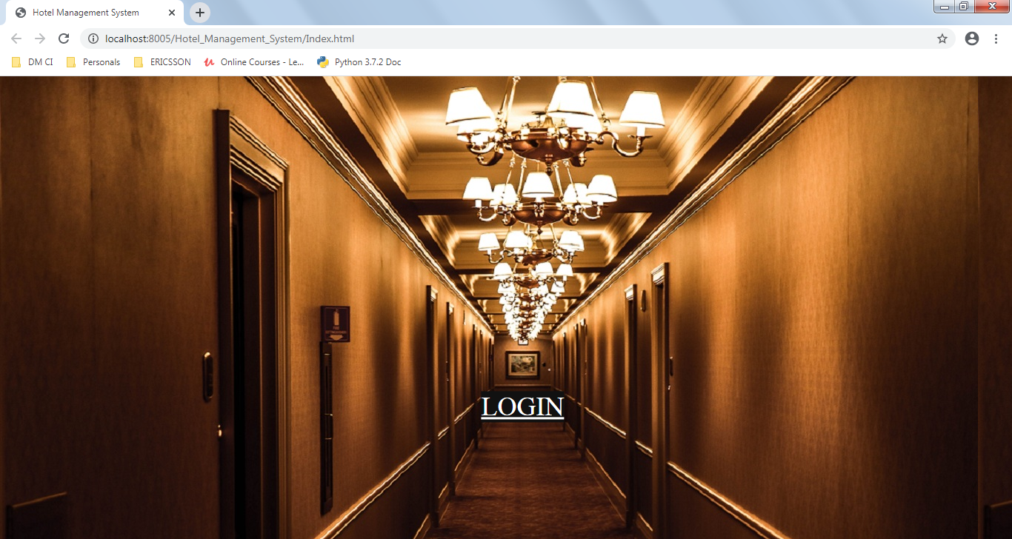

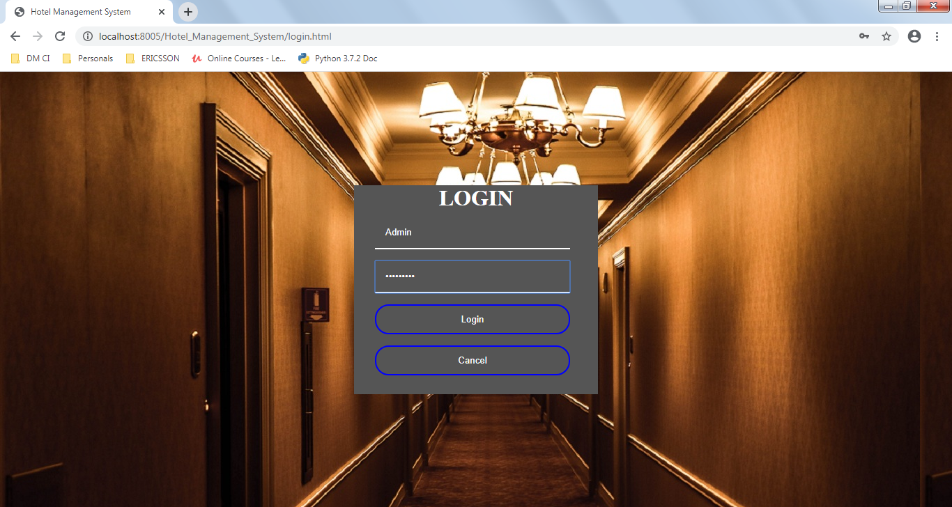

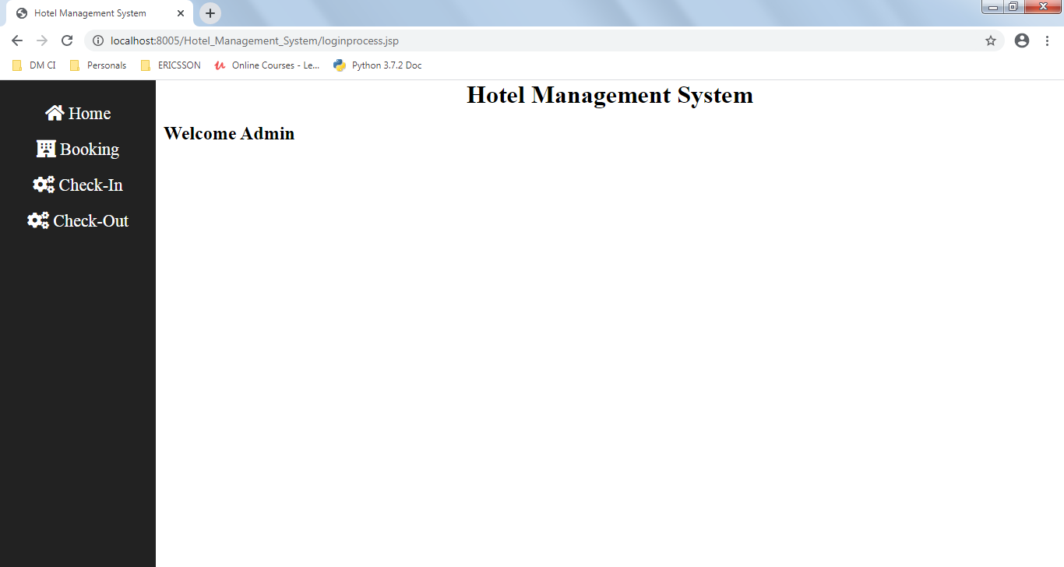

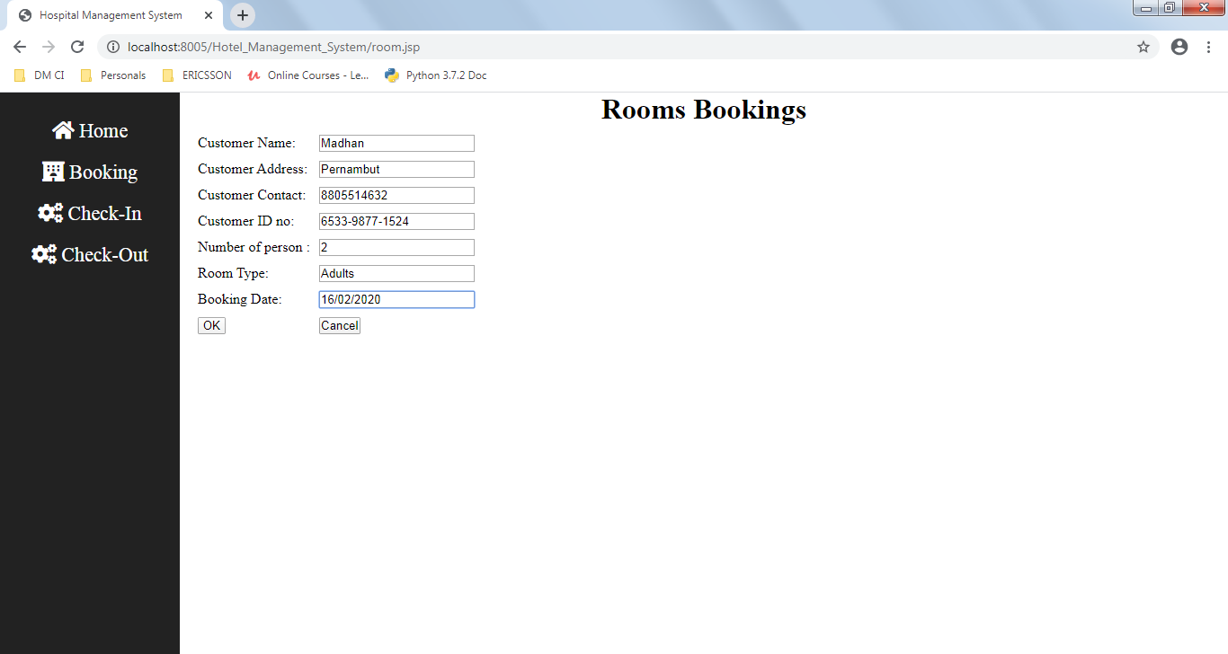

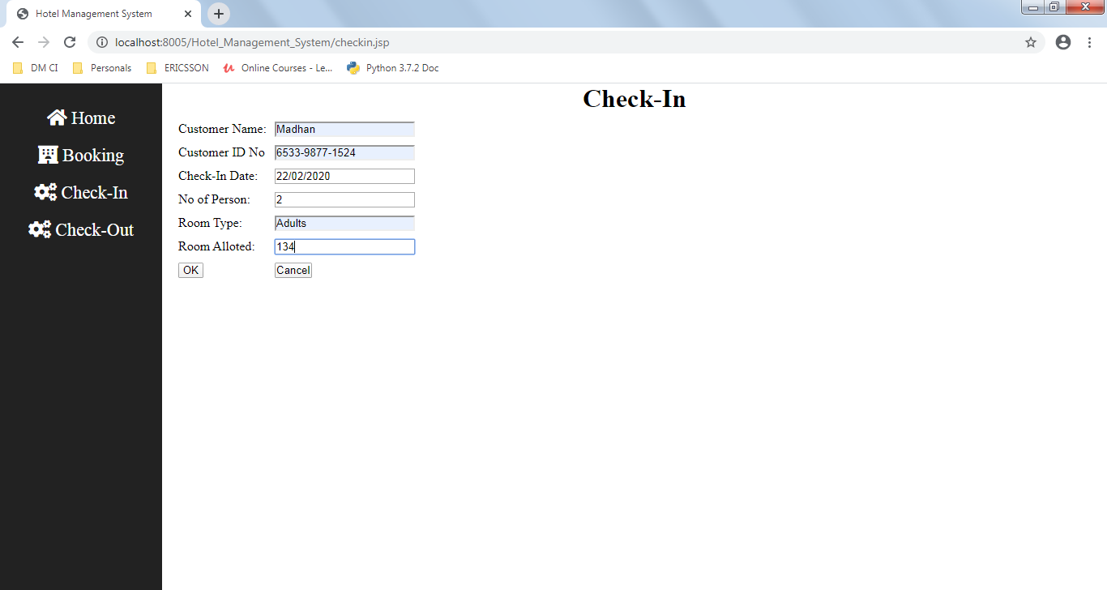

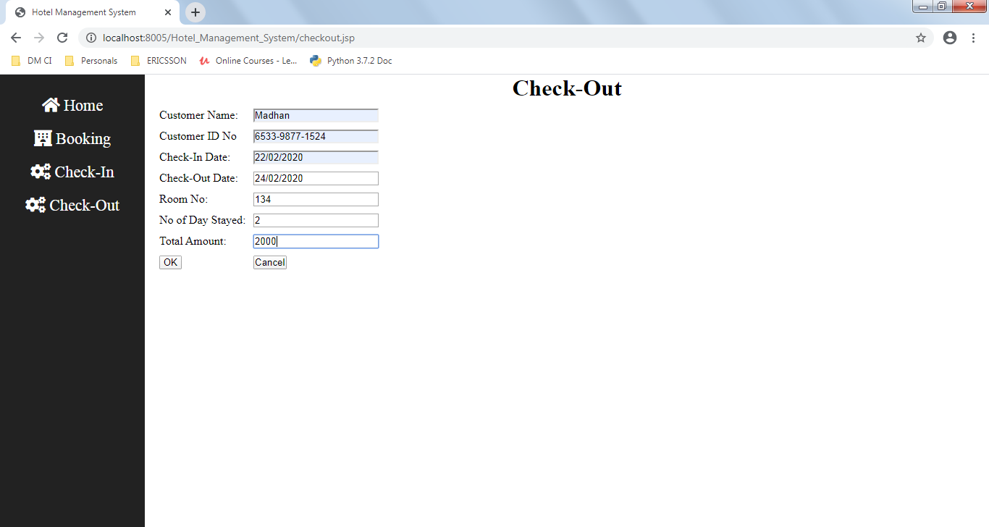

**CONCLUSION**

This Projects ”Hotel Management System” has been developed to provide and overcome the problem faced by the present system. The developed package was found to work out the operation in the present system. The developed package was found to work out the operation effectively. The objective was to reduce inconsistency, limiting redundancy , accessing data within less time to be achieved. It is user friendly, fast, secure and optimized. It helps to manage and provide more efficiency in work. This Projects is highly flexible for future addition and can adapt to any requirement.

**BIBLIOGRAPHY AND REFERENCES**

* Servlet and JSP Programming - By Uell Wahell, Mitch Fielding
* Core Servlet and Java Server Page - By Marty Hall , Larry Brown
* A beginner’s Tutorials Servlet and

JSP - By Budi Kurnia

**References:**

* A complete reference JSP - By Phill Hanna
* Tutorial Point - [www.tutorialpoint.com](http://www.tutorialpoint.com)
* Java Point - [www.javapoint.com](http://www.javapoint.com)
* W3School - [www.W3Schools.com](http://www.W3Schools.com)